

Cyberster Internship Program

Internship Report

BLUE TEAM

MUHAMMAD RAZA
ROLL NUMBER: CSI-B1-121

WEEK 1: LAB SETUP & SOC FOUNDATIONS

Overview
During the first week of my SOC internship, the primary objective was to build a defensive cybersecurity laboratory environment from scratch and understand the foundational mechanics of network monitoring and SIEM architecture. The tasks progressed from analyzing fundamental network traffic to deploying a fully functional Wazuh SIEM, connecting endpoint agents, and ultimately triaging live security alerts.
The lab consists of three virtual machines:
- Kali Linux: Attacker / Penetration Testing Machine
- Ubuntu Server: Wazuh Manager / SIEM
- Windows 10: Monitored Endpoint

DAY 1: NETWORKING FUNDAMENTALS FOR SOC

Task 01: OSI Model, TCP/IP, and Core Networking
Before analyzing live traffic or deploying virtual machines, it was critical to establish a foundational understanding of how network communication operates.
The OSI & TCP/IP Models: Networking communication is structured in layers. The OSI Model breaks this down into 7 layers: Physical, Data Link (MAC addresses/switches), Network (IP addresses/routing), Transport (TCP/UDP), Session, Presentation, and Application (HTTP/DNS). The TCP/IP Model is the practical implementation used on the internet, condensing this into 4 layers: Network Access, Internet, Transport, and Application. Understanding these layers allows a SOC analyst to isolate where an anomaly is occurring (e.g., a routing issue at the Network layer vs. a malicious payload at the Application layer).
Subnetting & IP Addressing: Subnetting involves dividing a large network into smaller, isolated, and more manageable networks. Using CIDR notation (like a /24 subnet mask), we can define the boundary between the network identifier and the host identifier. This is crucial for SOC analysts to determine if an IP address is communicating internally on a local network or reaching out to an external, potentially malicious, IP.

Common Ports for SOC Monitoring: Analysts frequently monitor specific ports for expected behavior. Anomalies on these ports often indicate compromise:
- Port 22 (SSH): Secure remote login.
- Port 80 (HTTP) & 443 (HTTPS): Standard web traffic.
- Port 53 (DNS): Domain name resolution.
- Port 445 (SMB): Windows file sharing (heavily monitored for lateral movement).
- Port 3389 (RDP): Remote Desktop Protocol.

Task 02: Protocol Analysis & Wireshark Capture
Using Wireshark, I captured live traffic to observe how everyday browsing translates into packet exchanges on the wire. Identifying normal traffic behavior is the first step in spotting anomalies.
Below is a summary of the core protocols analyzed during the capture:
- HTTP: Transmits data in cleartext. In a SOC context, unexpected HTTP traffic on non-standard ports often indicates command-and-control (C2) beacons.
- HTTPS/TLS: Encrypts web traffic. While the payload is secure, the TLS handshake reveals metadata such as the Server Name Indication (SNI), identifying the destination domain.
- ARP: Translates logical IP addresses into physical MAC addresses on a local network. A suspicious volume of ARP replies without corresponding requests can indicate ARP spoofing.
- DNS: Translates domain names into IP addresses. Anomalies such as massive TXT records or frequent queries to random subdomains may indicate DNS tunneling or data exfiltration.
- ICMP: Used for network diagnostics (e.g., ping). Suspicious ICMP activity might include abnormally large packet sizes or a high frequency of pings sweeping across a subnet.

Network Topology Diagram
I designed a secure architecture for the lab using VirtualBox, utilizing dual network adapters for each machine to ensure internal isolation while maintaining internet access for updates.

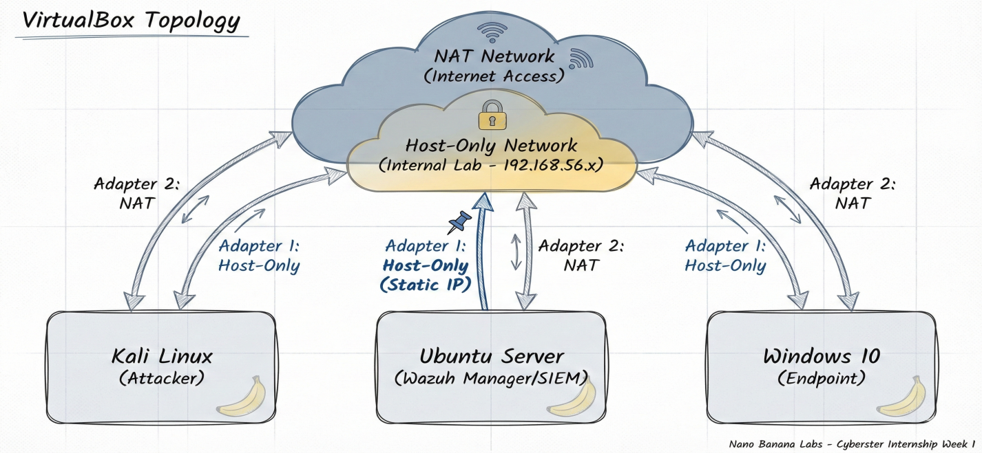

Protocol Captures
HTTP
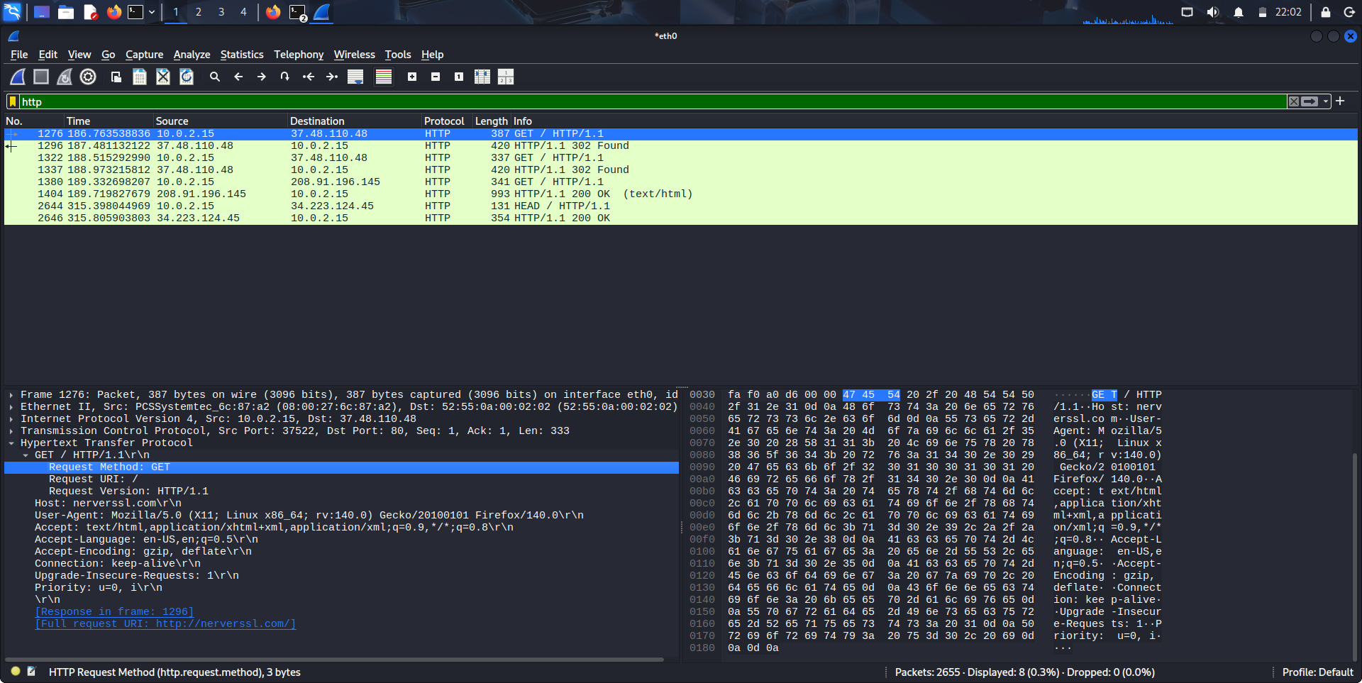
TLS
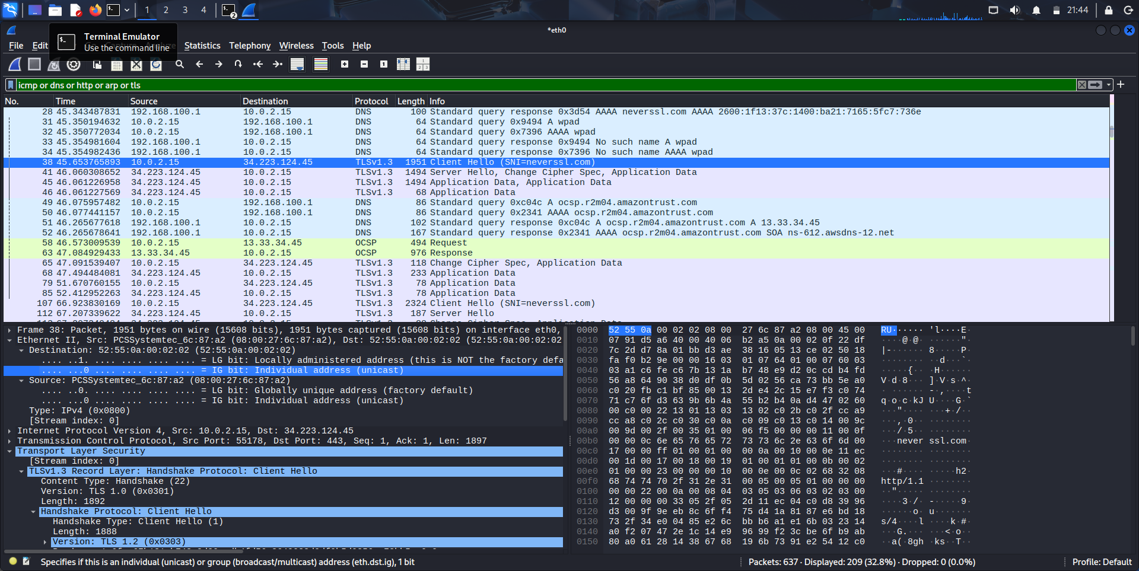
ARP
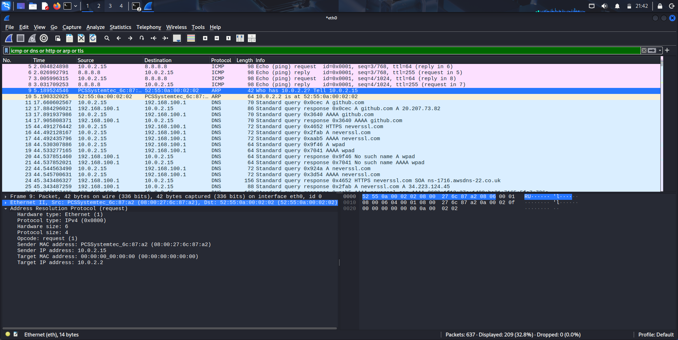
DNS
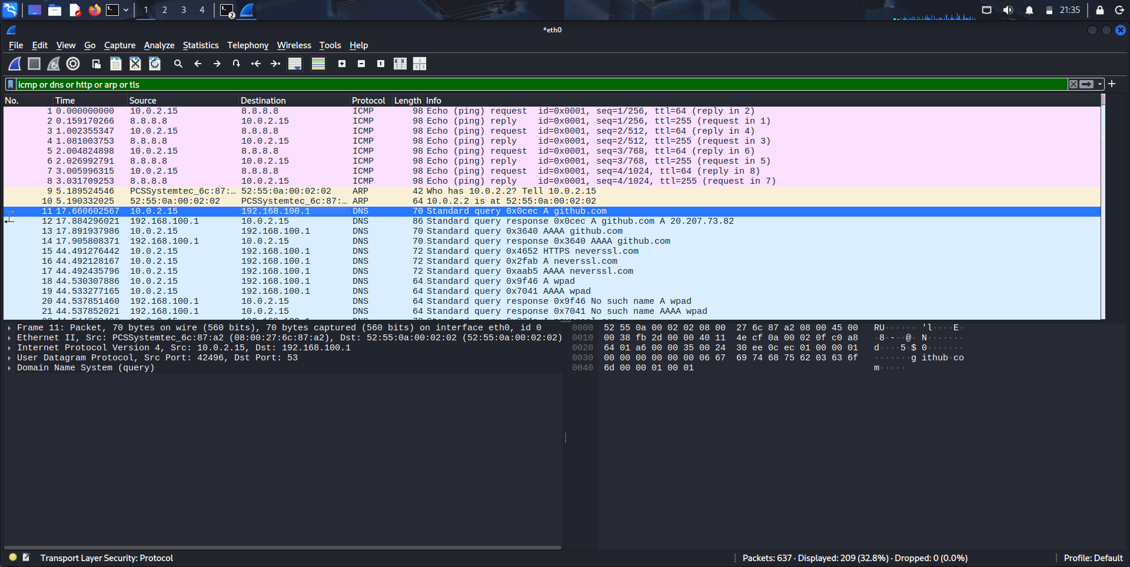
ICMP
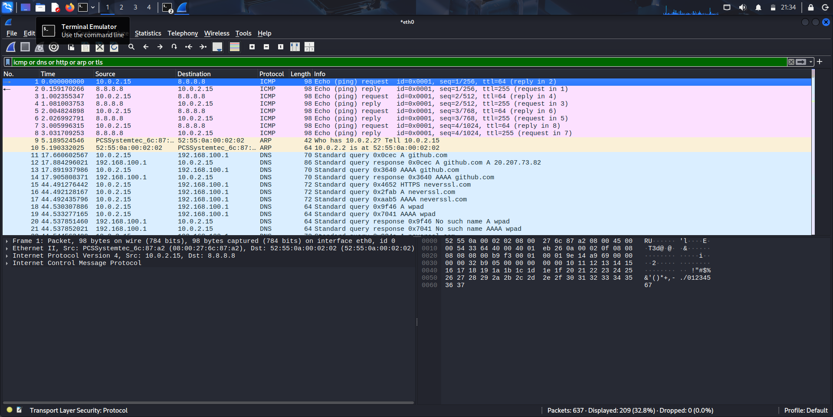

DAY 2: VIRTUALBOX LAB SETUP

Task 01: Virtual Machine & Network Configuration
I deployed the three required VMs (Kali, Ubuntu, Windows 10) in VirtualBox. To ensure the lab remains isolated but functional, I configured a dual-adapter setup for each machine:
- Adapter 1 (Host-Only Network): Assigned to the 192.168.56.x subnet. This provides a secure, internal network allowing the VMs to communicate directly with the Wazuh Manager without exposing lab traffic to the external network.
- Adapter 2 (NAT Network): Assigned to the 10.0.x.x range. This allows the VMs to reach the outside internet to download necessary updates and agent installers.

KALI LINUX
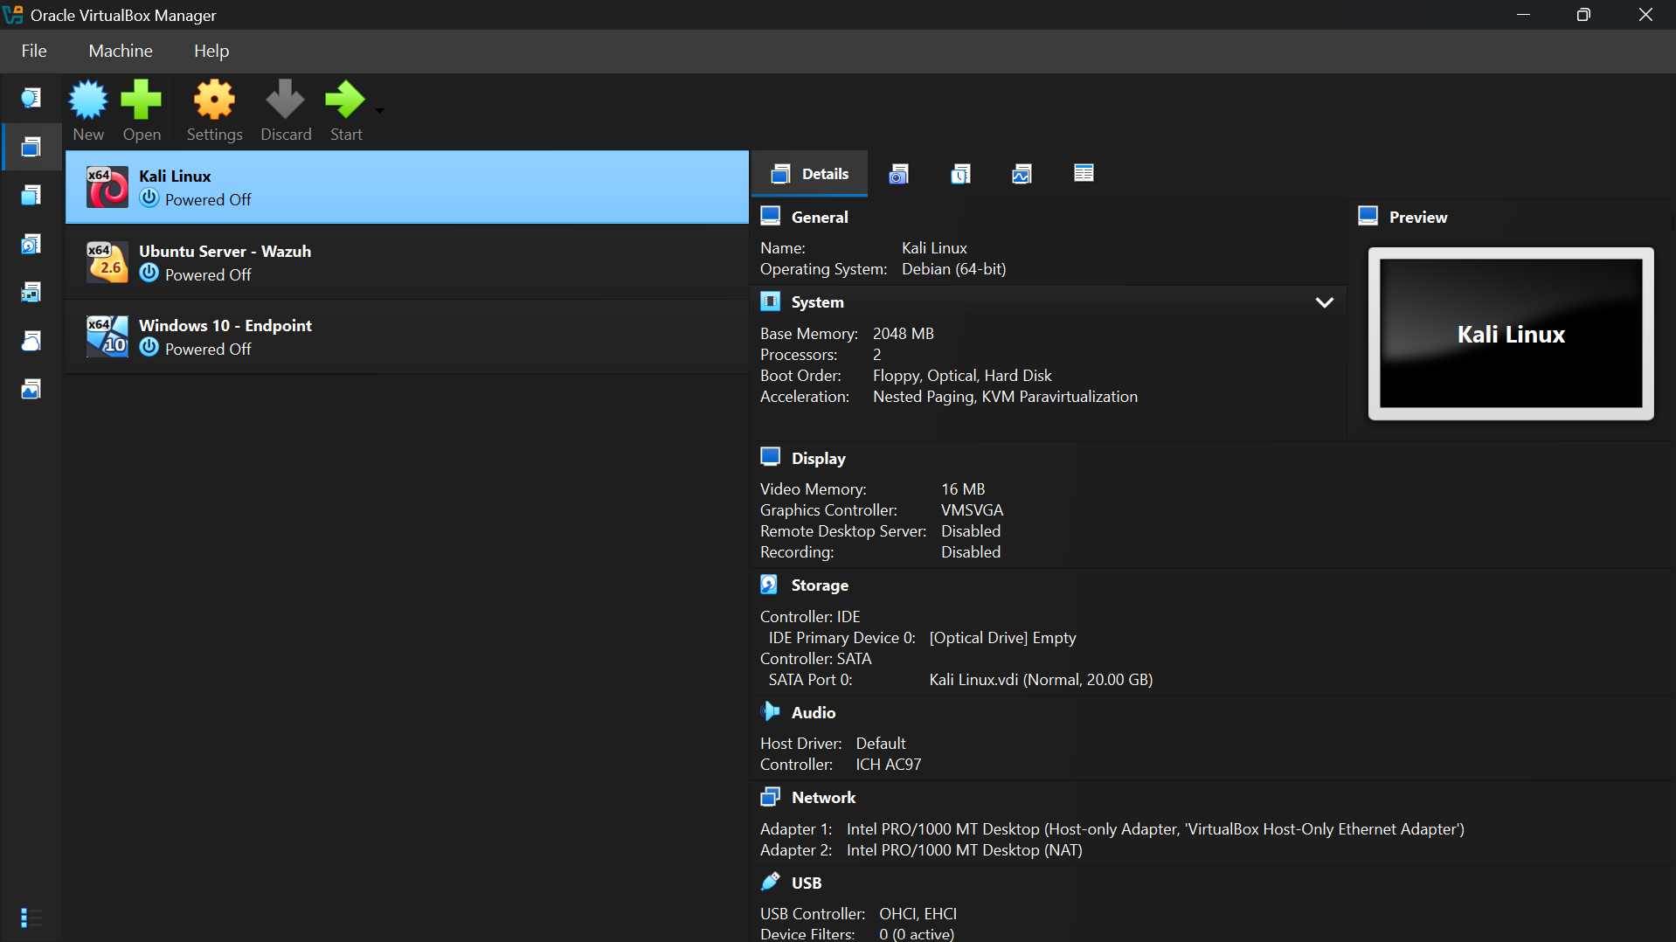
UBUNTU
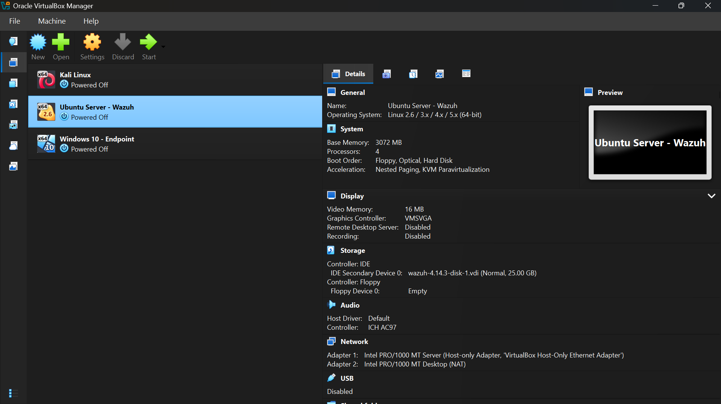

WINDOWS
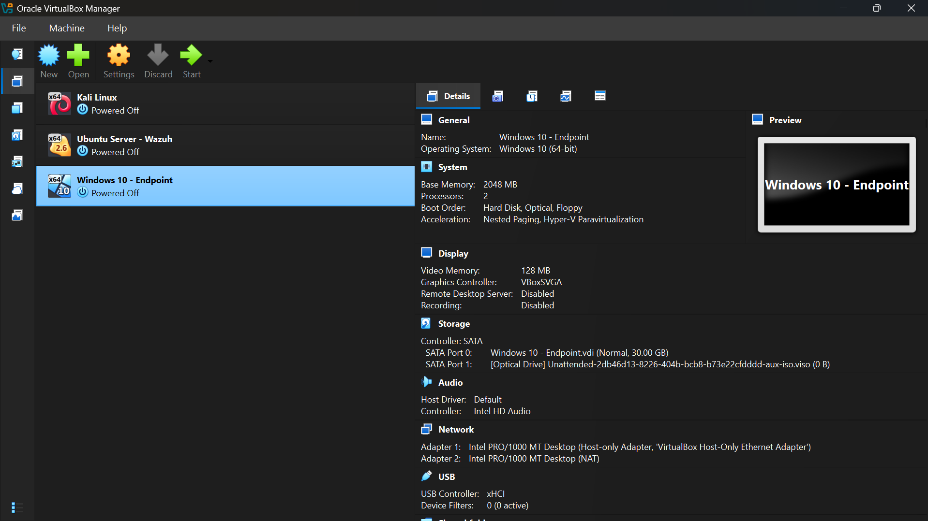

Task 02: Hardware Constraints & Architecture Pivot
During the deployment phase, I encountered resource limitations on my host machine. The standard Wazuh installation script requires a minimum of 4GB (preferably 8GB) of RAM allocated to the Ubuntu Server to prevent the Wazuh Indexer from failing. Running this alongside Kali and Windows simultaneously exceeded my host's physical RAM capacity.
Solution: To adapt to this hardware limitation, I pivoted from the manual installation script to deploying the pre-configured Wazuh OVA (Open Virtual Appliance). This provided an optimized Wazuh Manager and Indexer out of the box, bypassing the hardware bottleneck while achieving the exact same architectural goal. I utilized composite screenshotting to document the functional state of all VMs.

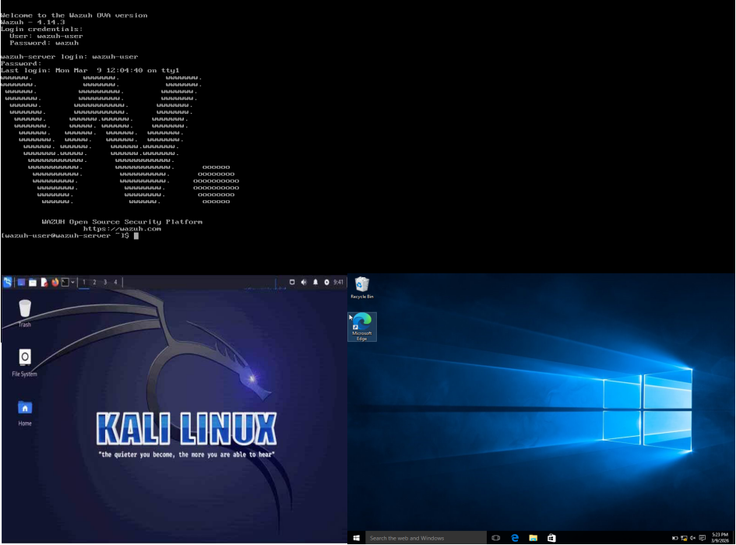

Task 03: IP Configuration and Connectivity Verification
I verified the IP addresses for the machines, ensuring they successfully pulled IPs from both the Host-Only and NAT DHCP servers.
KALI LINUX
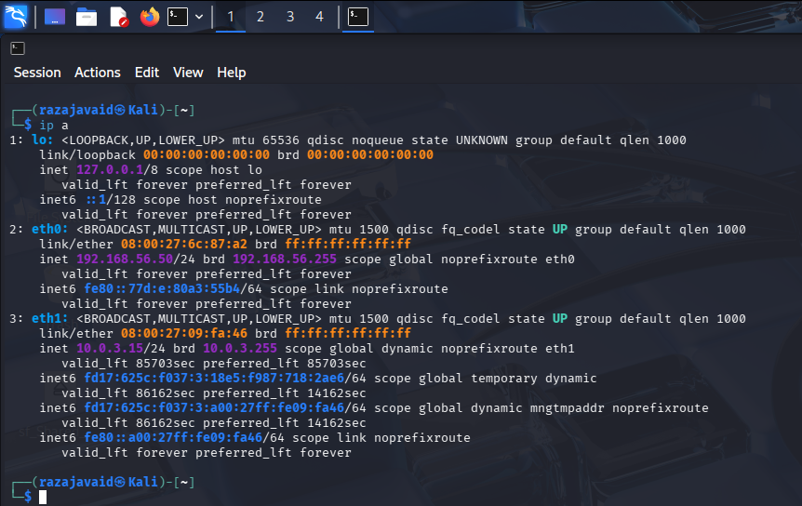
UBUNTU
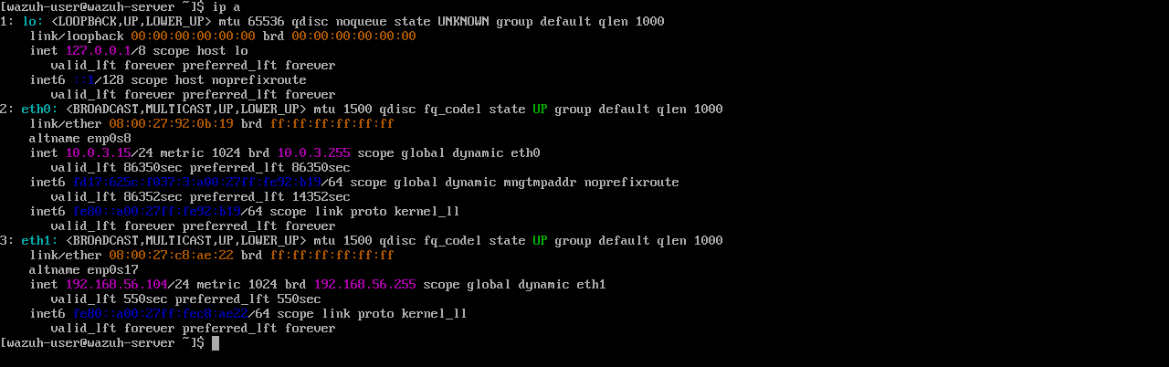
WINDOWS
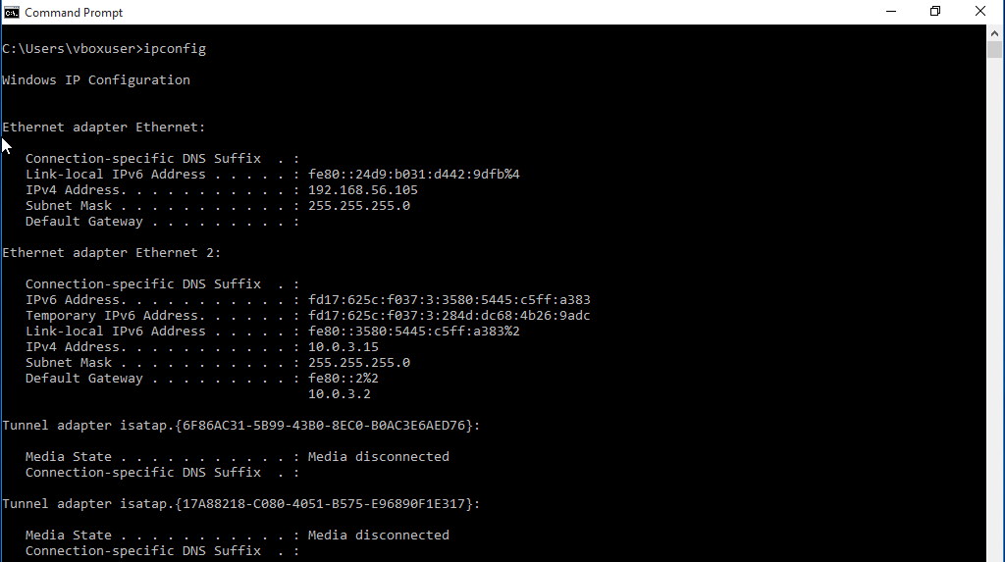

Next, I ran connectivity tests to confirm that all internal lab routing and external internet access were functioning correctly.

Internal Lab Connectivity Tests:
KALI LINUX TO UBUNTU
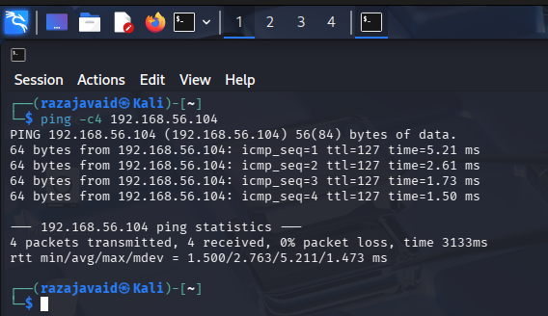
KALI LINUX TO WINDOWS
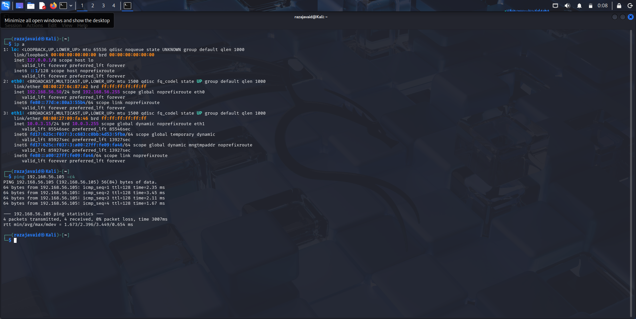
WINDOWS TO KALI LINUX
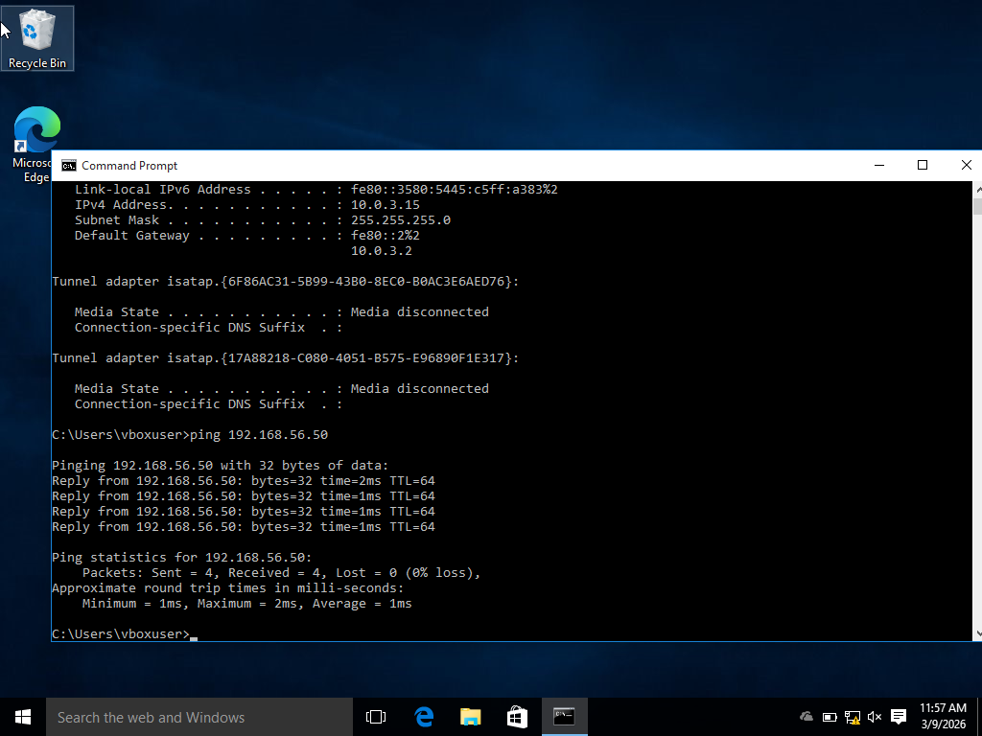
WINDOWS TO UBUNTU
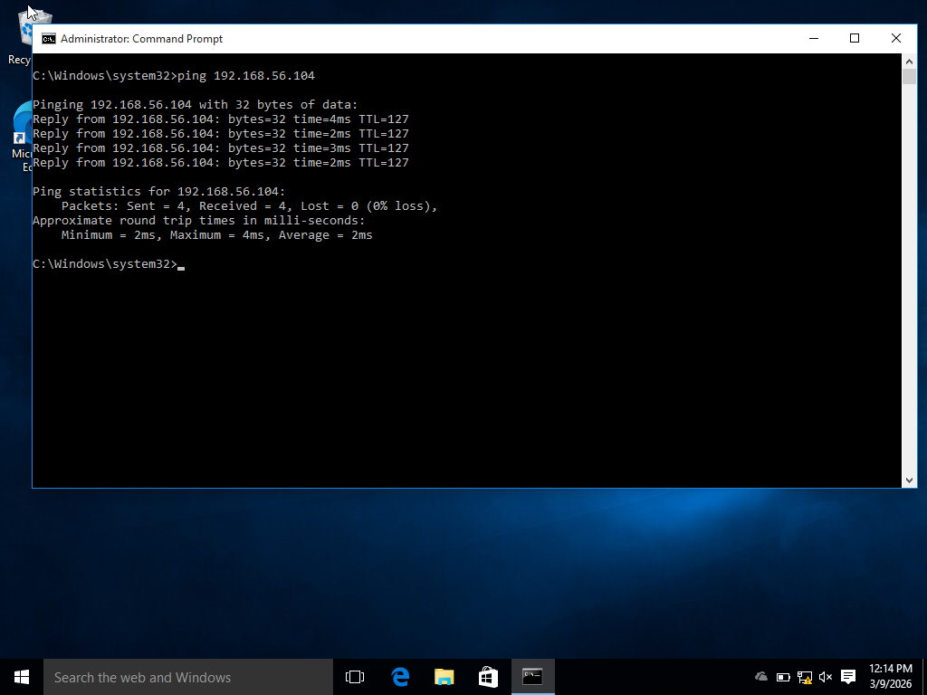
UBUNTU TO WINDOWS
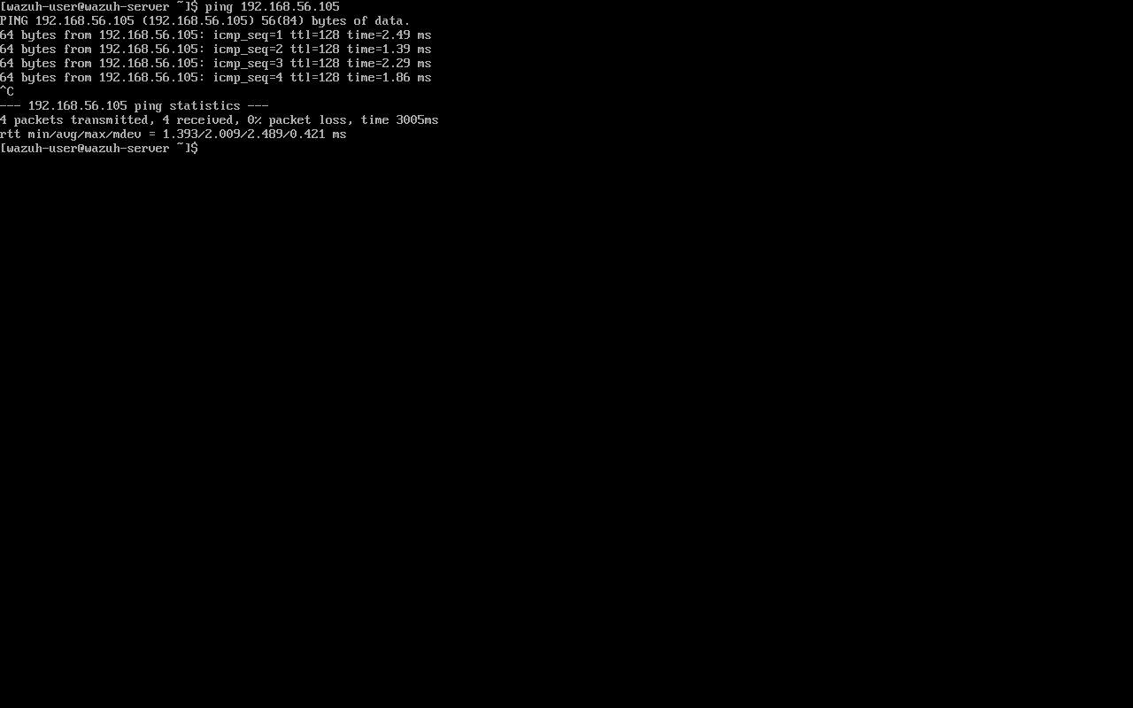
UBUNTU TO KALI LINUX
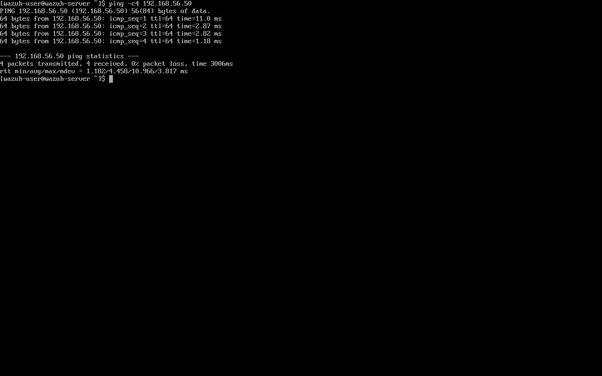

External Internet Connectivity Tests (NAT Verification):
KALI LINUX
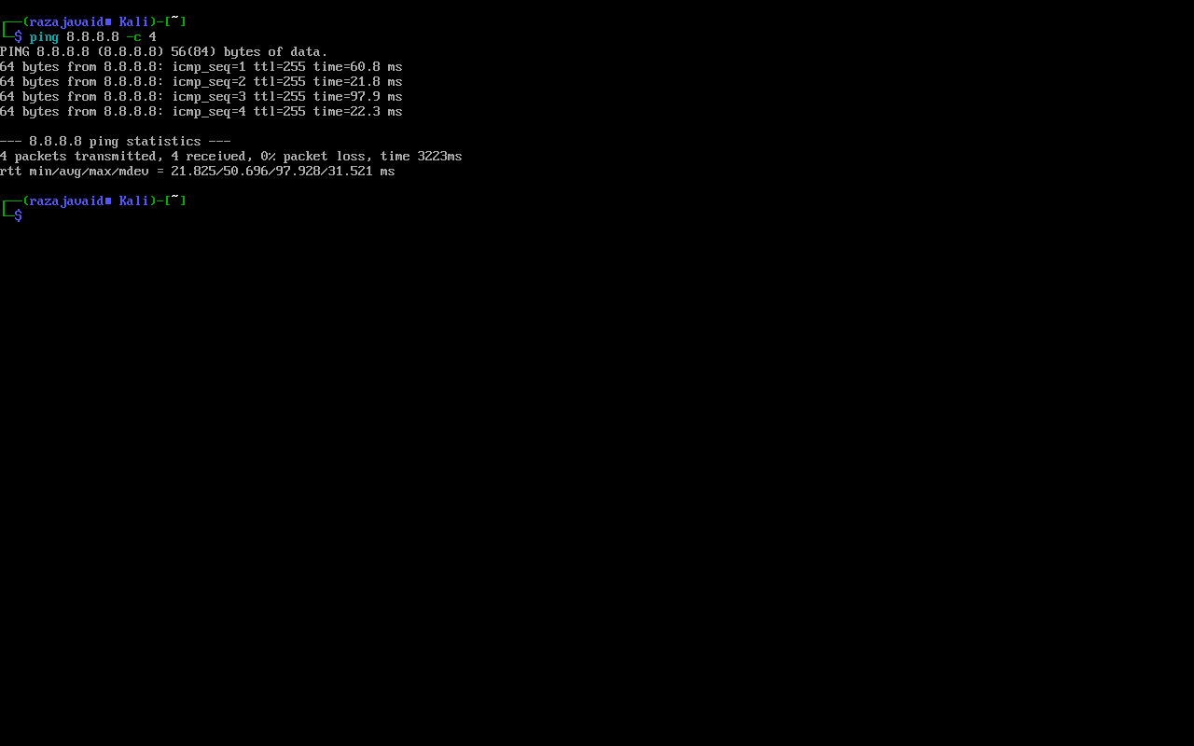
UBUNTU
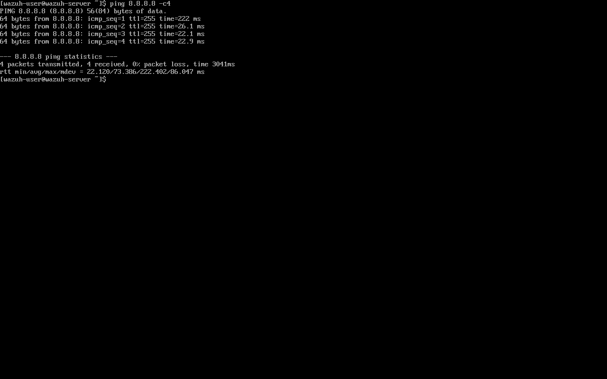
WINDOWS
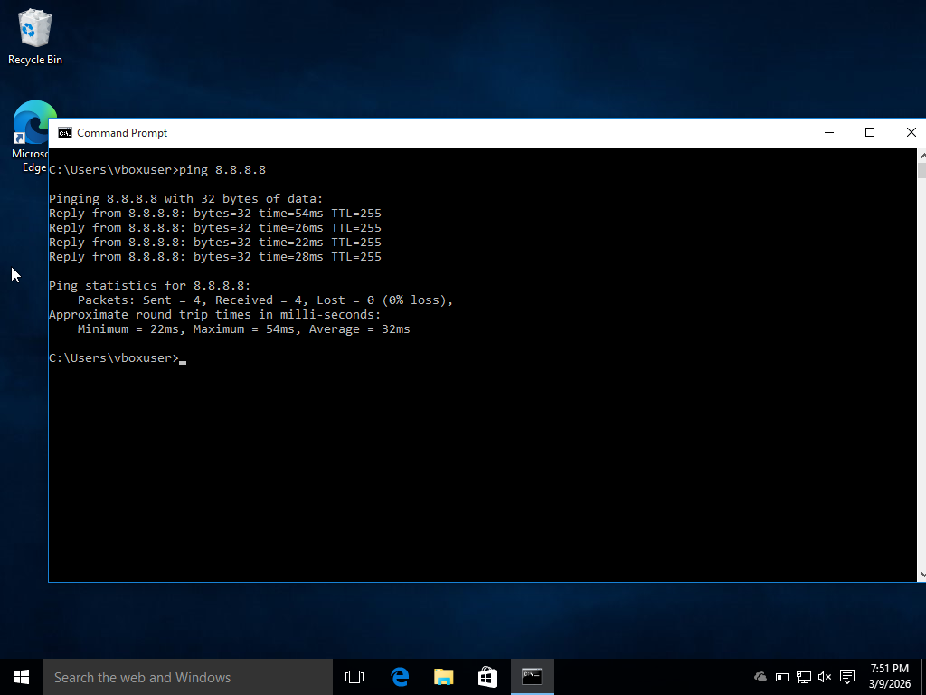

Task 04: VM Snapshots
With the network fully configured and tested, I took secure snapshots of all three machines. This established a safe rollback point before altering system files during agent deployment.
KALI LINUX
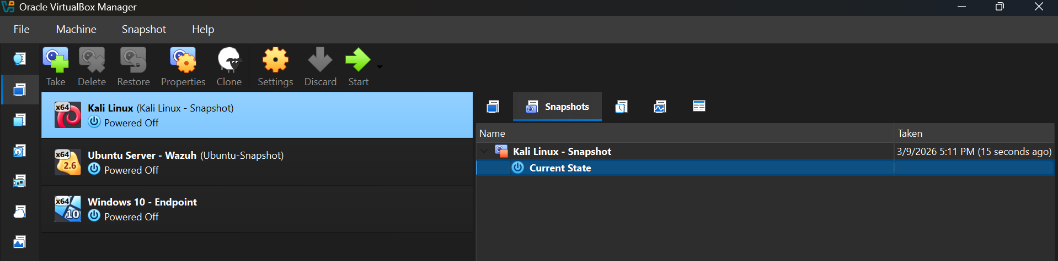
UBUNTU
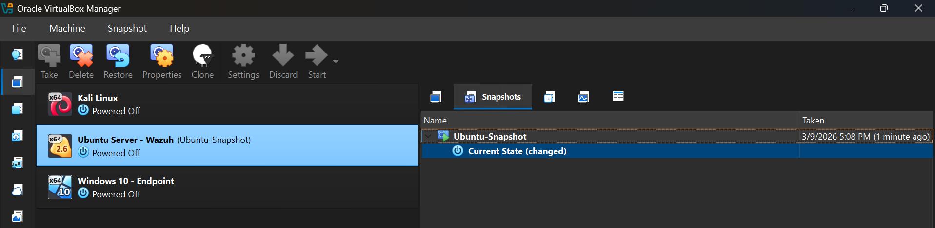
WINDOWS
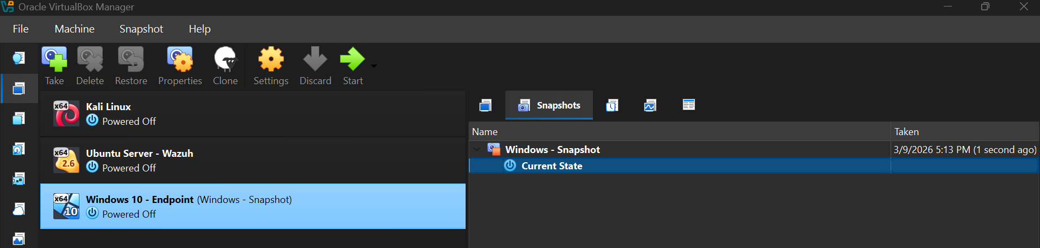

DAYS 3 & 4: WAZUH MANAGER INSTALLATION

Task 01: Wazuh Configuration
As noted in Day 2, I successfully deployed the Wazuh OVA to manage system resources. I assigned a static IP address (192.168.56.104) to the Ubuntu Server on the Host-Only interface. This step is critical to ensure that endpoint agents do not lose connection to the manager if a DHCP lease expires.
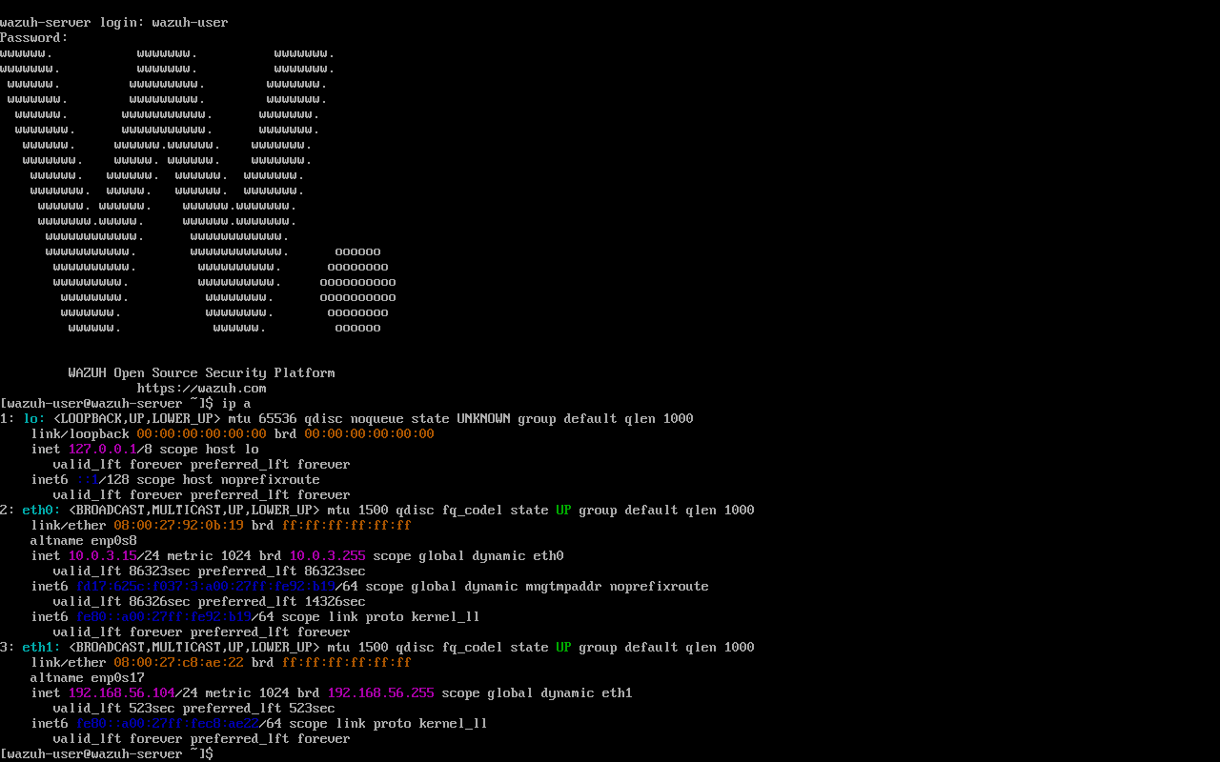

Task 02: Accessing the Dashboard
Once the Wazuh Manager, Indexer, and Dashboard services initialized, I accessed the web interface via the host browser, confirming the SIEM was active and ready to receive telemetry.
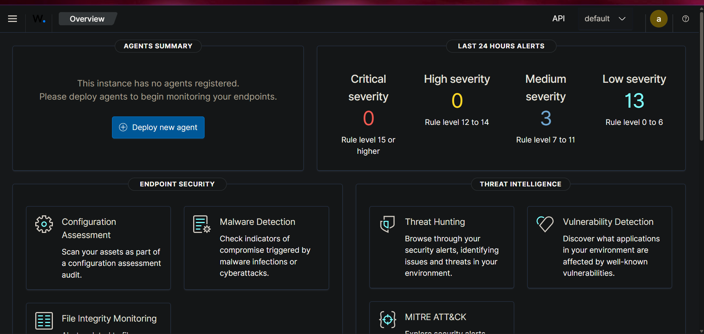

DAYS 5 & 6: WAZUH AGENT DEPLOYMENT

Task 01: Deploying Agents to Endpoints
To gain visibility into the network, I deployed Wazuh Agents to both the Kali Linux and Windows 10 endpoints. I used the Wazuh Dashboard deployment wizard to generate the installation commands, pointing them to the static IP of the Wazuh Manager (192.168.56.104).
After installing the packages, I verified the ossec.conf file on the Kali machine to ensure the <client> block was correctly pointing to the manager.
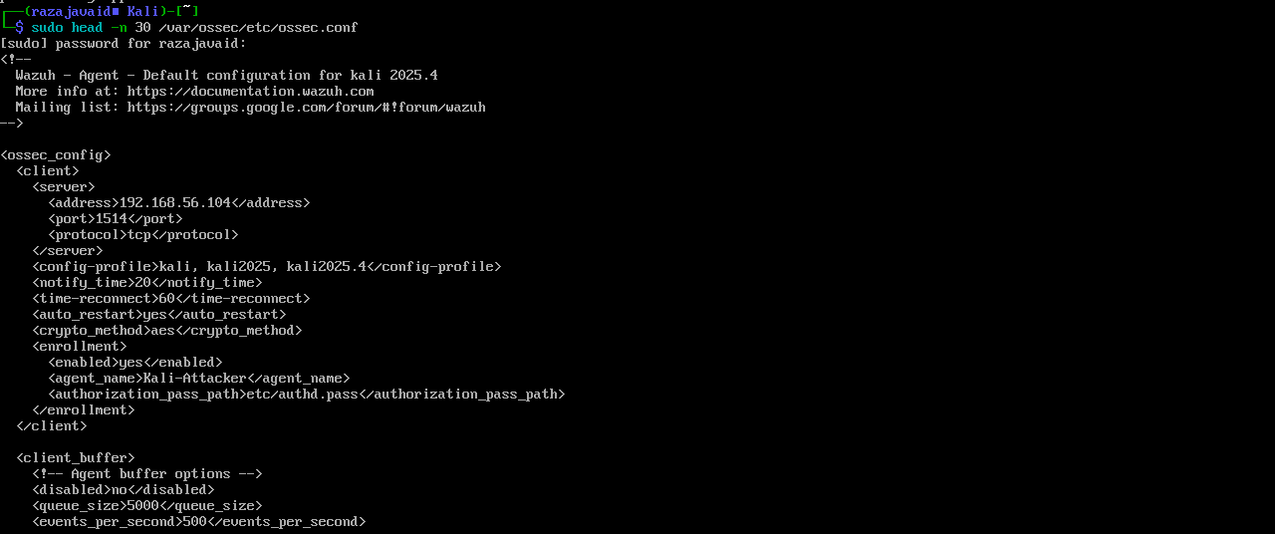
After starting the agent services, both endpoints successfully registered and appeared as "Active" in the Wazuh dashboard.
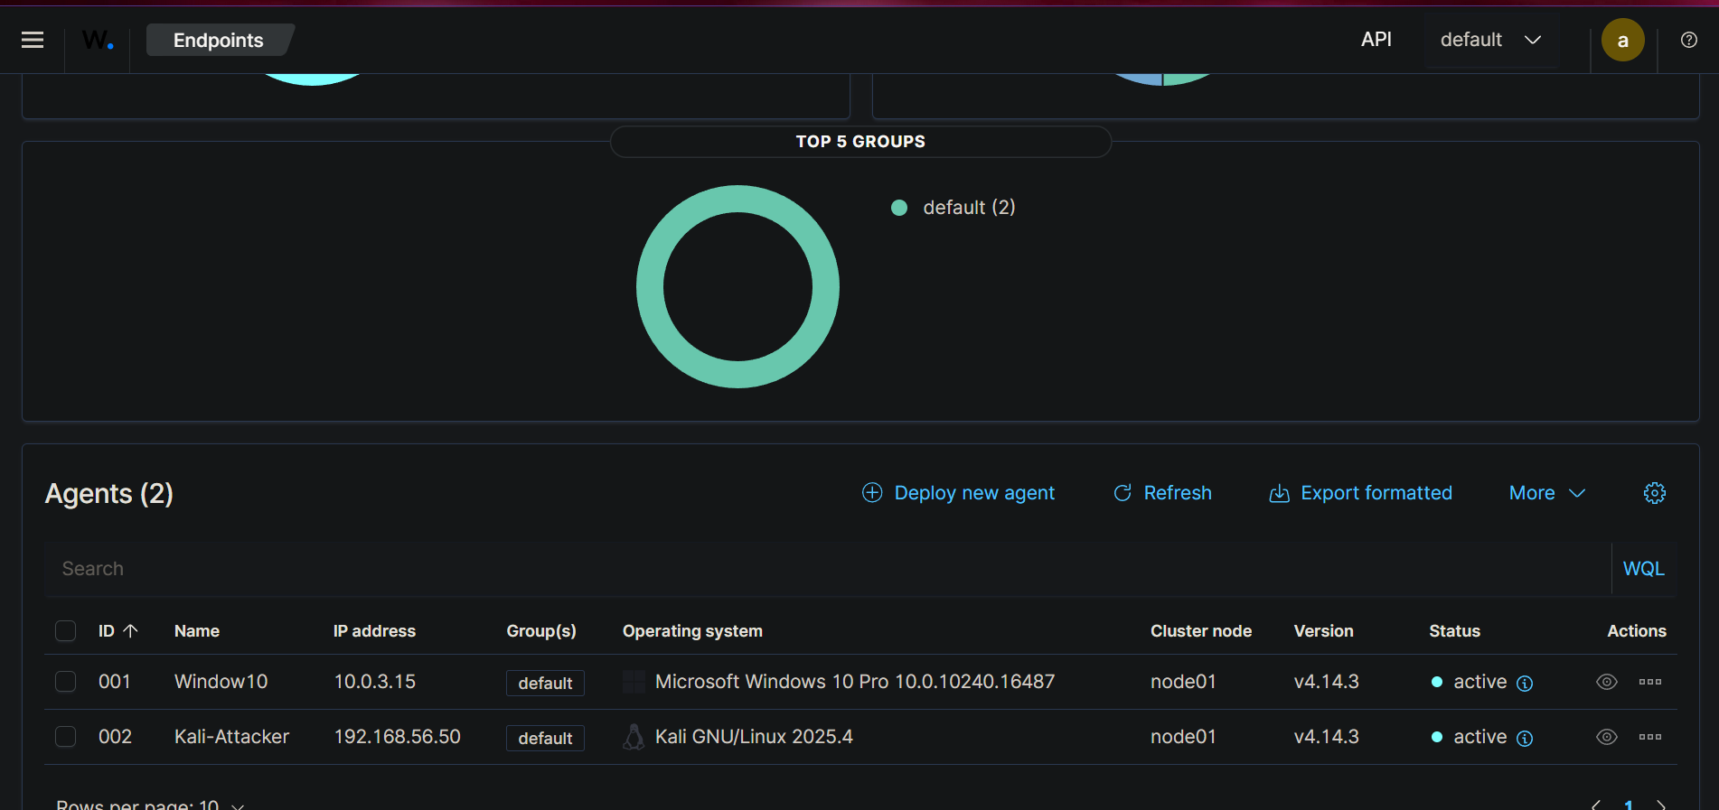

Task 02: Generating Test Alerts (Threat Simulation)
To confirm the data pipeline was actively processing logs and triggering rules, I simulated attacks and system changes against the environment.
Simulation 1: SSH Brute Force (Network Attack)
From the Kali Linux machine, I intentionally spammed failed SSH login attempts against a non-existent user on the Ubuntu Server to trigger an authentication alert.
SSH BRUTE FORCE ATTACK
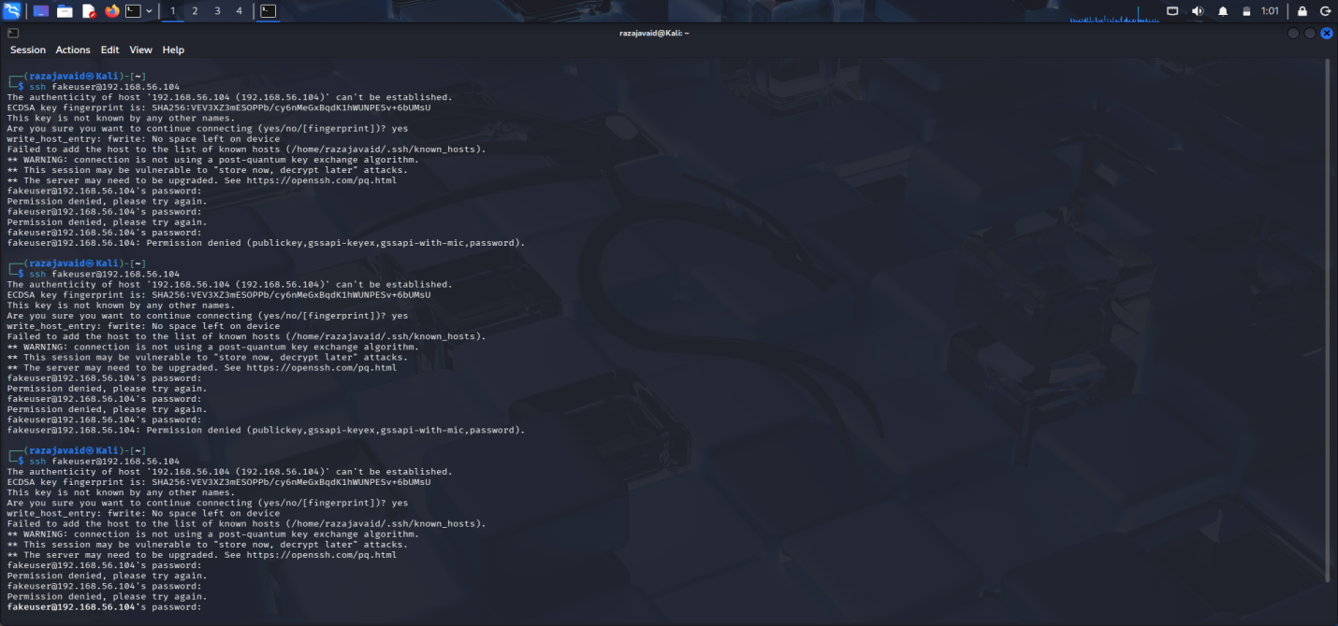
WAZUH CATCHES SSH ATTACK
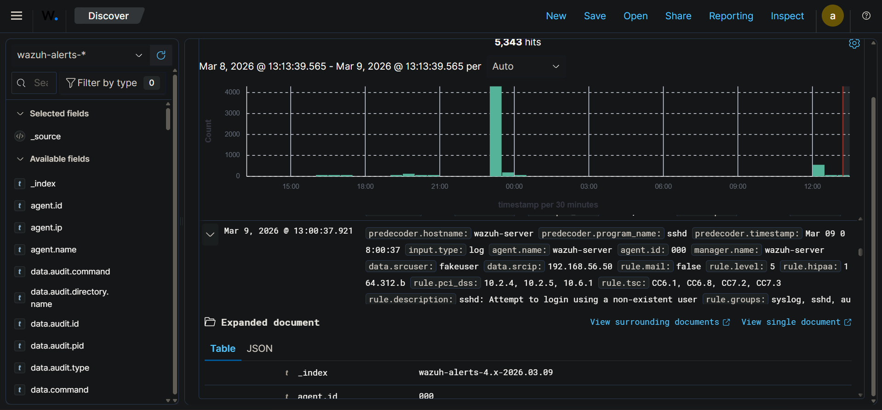
WAZUH SSH ALERT
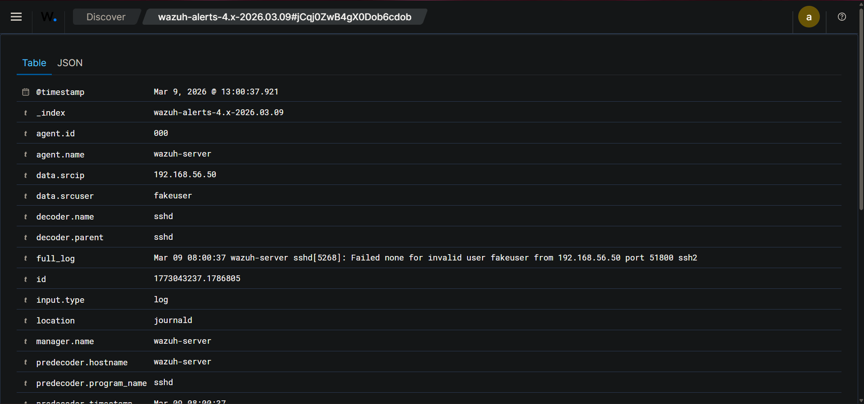
Simulation 2: Privilege Escalation / Backdoor Creation (Endpoint Attack)
On the Windows 10 machine, I opened an elevated command prompt and executed net user BackdoorAdmin P@ssw0rd123! /add to simulate an attacker establishing persistence. Wazuh successfully caught the user creation event.
WINDOWS BACKDOOR TEST
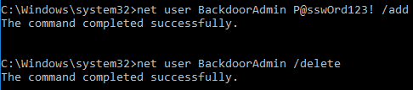
WINDOWS ALERT CAUGHT
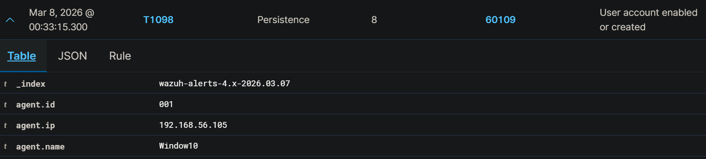
Simulation 3: PowerShell Telemetry Testing
To verify extended visibility, I executed PowerShell commands on the endpoint and observed the corresponding telemetry populated in the SIEM.
POWERSHELL TELEMETRY TEST
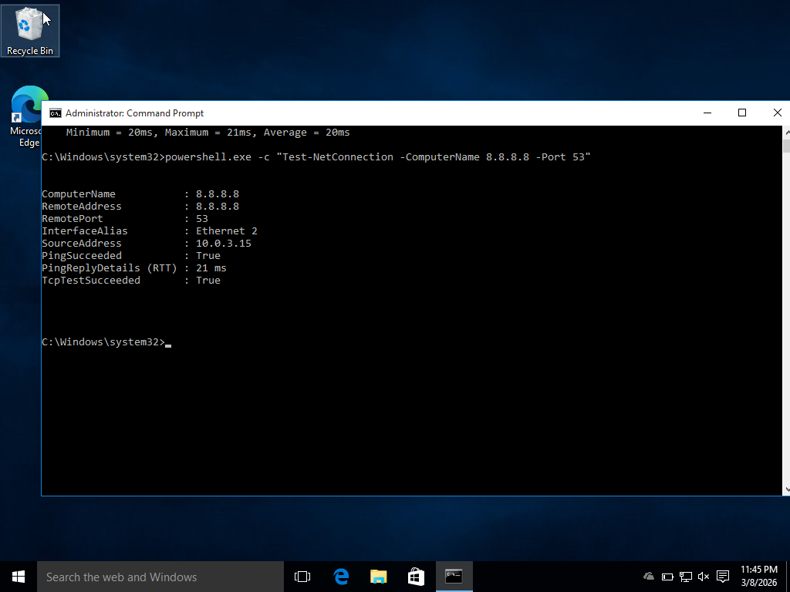
TELEMETRY ALERT CAUGHT
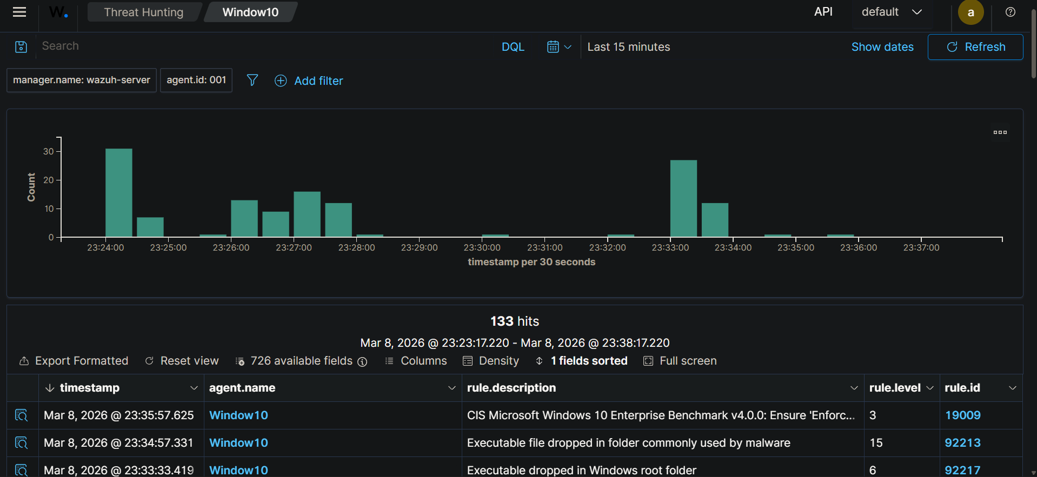

TELEMETRY ALERT DETAILS
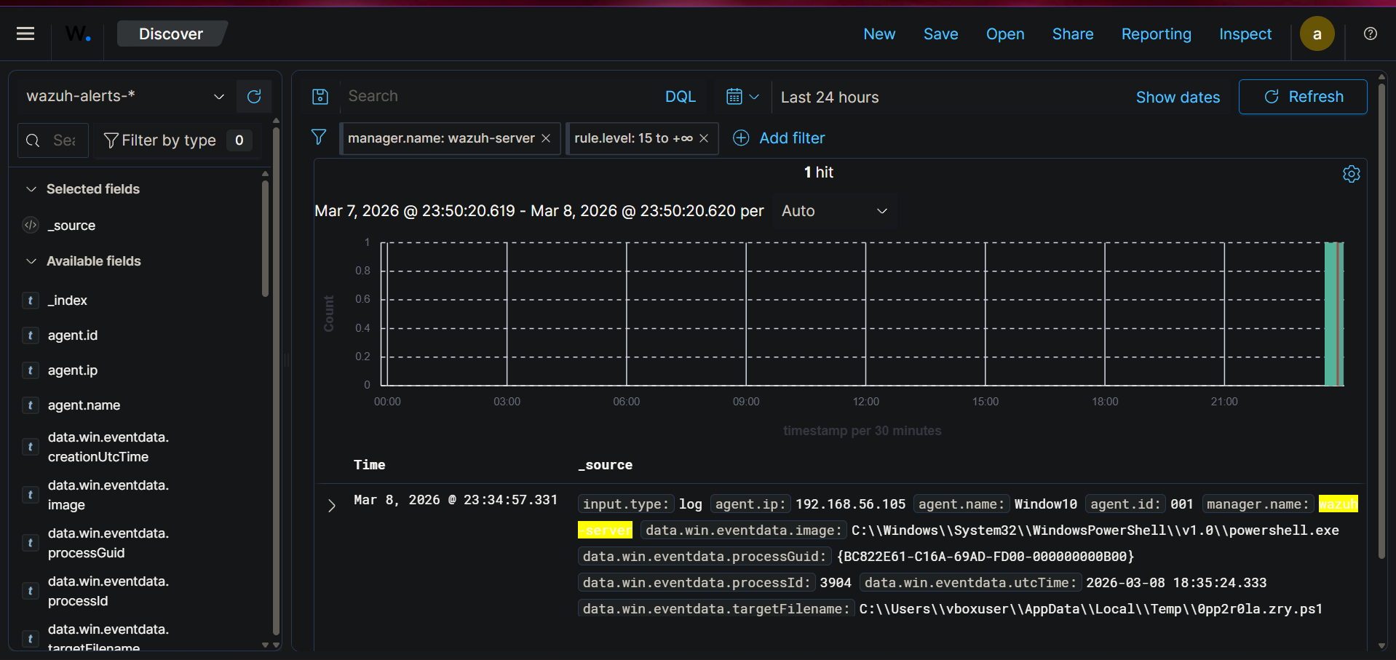

DAY 7: DASHBOARD NAVIGATION & ALERT TRIAGE

Task 01: Exploring the SIEM Modules
I utilized the dashboard to shift from deployment to active analysis, focusing heavily on the Threat Hunting and MITRE ATT&CK modules to map the generated alerts to industry-standard adversary tactics.
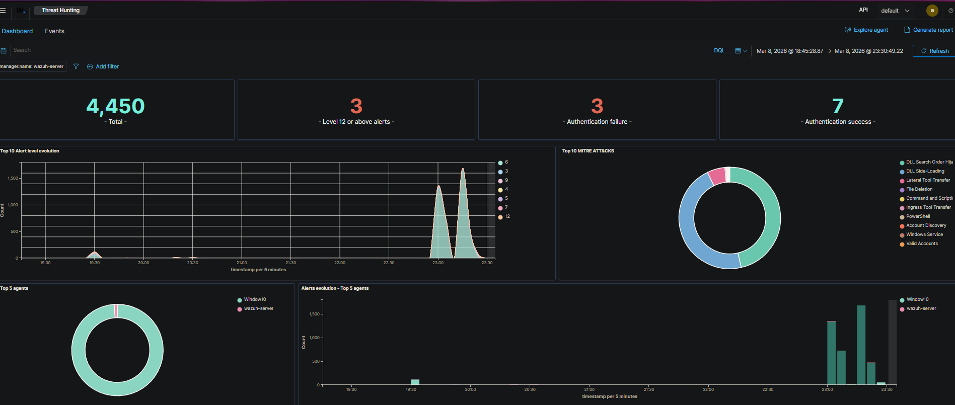

Task 02: Environmental Baseline (Top 10 Alerts)
To understand what "normal" looks like in my specific lab environment, I identified the top 10 most frequently occurring alert types over the last 24 hours.
Rank | Rule ID | Level | Rule Description | Assessment
1 | 92217 | 6 | Executable dropped in Windows root folder | Routine Activity: Due to recent VM setup and software installations, a high volume of dropped executables is expected baseline noise.
2 | 80730 | 3 | Auditd: SELinux permission check | Routine Activity: Standard background telemetry generated by the Linux kernel enforcing permissions securely.
3 | 510 | 7 | Host-based anomaly detection event (rootcheck) | Routine Activity: Indicates the Wazuh agent is successfully performing its scheduled baseline rootkit scans.
4 | 5501 | 3 | PAM: Login session opened | Routine Activity: Expected administrative behavior as I am actively logging into the Linux machines to configure them.
5 | 5716 | 5 | sshd: Attempt to login using a non-existent user | Genuine Concern (Simulated): Caught my intentional SSH brute-force simulation from Kali.
6 | 60790 | 4 | The registry file is still in use by other applications | Routine Activity: Standard Windows OS behavior occurring during normal background service operations.
7 | 60137 | 3 | Windows User Logoff | Routine Activity: Standard audit logging confirming a user session has ended.
8 | 92219 | 6 | Possible DLL search order hijack | False Positive: Triggered by wuapi.dll, which is the built-in Windows Update service staging routine patches.
9 | 92021 | 3 | Powershell was used to delete files or directories | Routine Activity: Likely an automated background cleanup script running after Windows updates in this fresh VM.
10 | 60646 | 5 | License activation (slui.exe) failed | Routine Activity: The temporary Windows lab VM lacks a paid license key, generating errors with zero security impact.

Task 03: Critical Alert Triage (Ransomware Simulation)
To push the Threat Hunting module to its limits, I executed a simulated Ransomware command on the Windows 10 endpoint: vssadmin delete shadows /all /quiet. Ransomware strains commonly use this command to delete volume shadow copies so victims cannot restore their files.
Wazuh instantly caught this telemetry via Sysmon and categorized it as a Level 12 CRITICAL alert.
SIMULATED RANSOMWARE EXECUTION
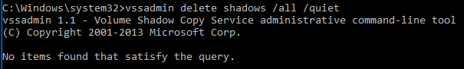
RANSOMWARE CRITICAL ERROR
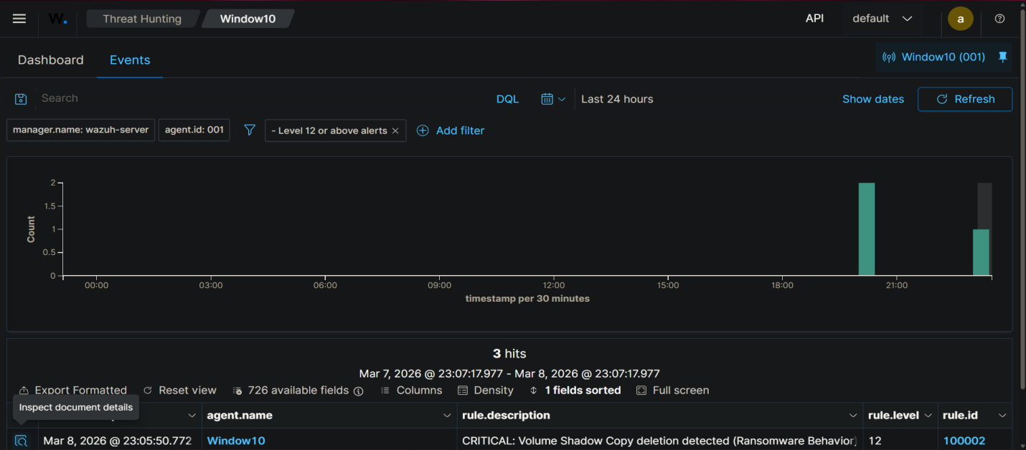
RANSOMWARE ALERT DETAILS
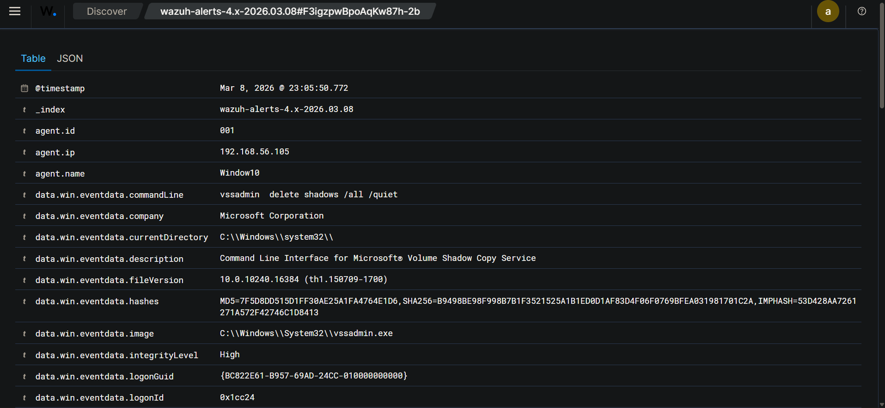
Triage Analysis:
- What is the alert? Rule 100002 triggered, detecting the specific command line arguments used to delete shadow volume copies.
- Is it a false positive? No, it is a True Positive catching my simulated attack.
- Action Required: In a production environment, this would warrant immediate isolation of the Windows host from the network and an incident response investigation into how the attacker gained code execution.
End of Week 1 Report

